Romantic Illustration Network
http://romanticillustrationnetwork.wordpress.com/
Second Event
‘The Artist and the Writer’
Supported by the British Association for Victorian Studies (BAVS): http://www.bavs.ac.uk/ , and the University of Roehampton
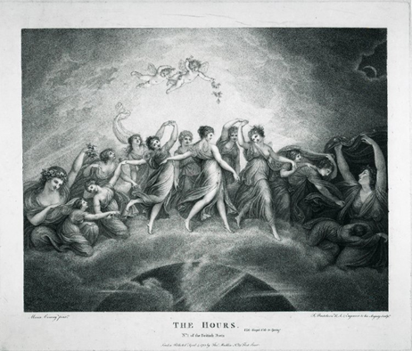
Saturday 29th November, 2014, 10am – 5.35pm
Institute of English Studies, Senate House, University of London,
Malet Street, London WC1E 7HU

10.00 Registration and Welcome
10.15 Lynn Shepherd (Richardson scholar and novelist): ‘Reading Pamela, picturing Pamela: Samuel Richardson illustrates his novel’
(Chair: Mary L. Shannon, Roehampton)
11.00 tea and coffee
11.30 Sandro Jung (Ghent): 'Thomas Stothard, Romantic Literature, and the Illustrative Vignette'
12.15 Tim Fulford (De Montfort): ‘William Westall and the Lake Poets’
(Chair: Ian Haywood, Roehampton)
1.00 sandwich lunch
2.00 Visit to Senate House Library Special Collections Reading Room
2.30 Sophie Thomas (Ryerson, Canada): ‘Bardic Exhibitionism: Illustration and the ‘Open’ Text in Blake and Gray’
(Chair: Susan Matthews, Roehampton)
3.15 tea and coffee
3.35 Mary L. Shannon (Roehampton): ‘What Did Dickens Learn From Romantic Illustration?’
4.20 Ruth Richardson (King’s College London; Cambridge): ‘Dickens, Cruikshank, and Oliver Twist’
(Chair: Ian Haywood, Roehampton)
5.05 Open discussion
5.35 Close. Please join us for a drink at The Marquis of Cornwallis: http://www.themarquiscornwalliswc1.co.uk/findus/

